Low-Level Architecture and Data Models

P07: Automated Compliance Auditing Software integrated using Ai

<team member names & ids>

Student ID | Name
25100277 | Ammad Akram Khan
25100132 | Shabbir Kamal
25100279 | Rida Bilgrami
25100162 | S. M. Aqdas Rizvi

Content | Totals | Obtained
Architecture diagram | 20 | 15
Architecture justification | 20 | 18
E/R diagram | 20 | 15
E/R diagram description | 20 | 17
Tools and Technologies | 10 | 10
Who did what | 3 | 3
Review checklist | 2 | 2
Overall formatting/template | 5 | 5
GitHub folder structure penalty | -15 | -
Late submission penalty | -20 | -
Grand Total | 100 | 85
General Comments/Individual Grading:
Update as the high level architecture.

Table of Contents

1. Introduction 3
2. System Architecture 4
2.1 Architecture Diagram—As it is in the prototype code 4
2.2 Architecture Diagram—As it should-be 4
3. Data Models 5
4. Tools and Technologies 6
5. Who Did What? 7
6. Review checklist 7

Introduction

Overview: ACASA (Automated Compliance Auditing Software using AI) aims to automate the auditing of compliance standards such as HIPAA, ISO 27001, PCI-DSS, and GDPR. It utilizes open-source libraries and AI-driven decision-making to address current market gaps, particularly by offering a cost-effective, fully automated solution. ACASA targets organizations needing to streamline compliance processes, reducing human intervention and error, while improving audit accuracy and efficiency.

Potential Users:

Compliance Officers

IT Security Teams

Executives

Auditors

System Architecture

Architecture Diagram—As it is in the prototype code
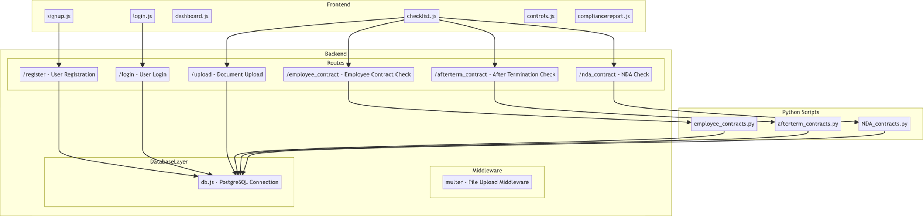

- This architecture achieves a layered structure where:
  - The frontend handles UI, user interaction, and state management.
  - The backend serves as the core logic layer, managing requests, data storage, and file processing.
  - The Python scripts perform specialized analysis tasks with AI, enabling automation for compliance assessments.

- Frontend Layer
  - This layer consists of the React components that form the user interface of the compliance auditing web application. Each component serves specific roles for handling user interactions, data input, and navigation across various app sections:
    - signup.js and login.js:
      - Handles user registration and login.
      - Sends user credentials to the backend for processing through API endpoints.
      - Receives feedback (success or error messages) from the backend to display to the user.
    - dashboard.js:
      - Acts as the main interface after login, showing the compliance checklist and providing options to generate compliance reports.
      - Manages overall compliance progress, passing data to other components as needed.
    - checklist.js:
      - Represents the core of compliance management.
      - Displays a list of compliance controls, tracking which ones have been checked or completed.
      - Allows users to upload documents for verification and initiate automated compliance checks through backend requests.
    - controls.js:
      - Represents individual compliance controls, each having an associated checkbox for marking completion and a file upload feature.
      - Sends uploaded files to the backend and updates compliance status based on backend responses.
    - compliancereport.js:
      - Generates a summary report based on the completion percentage of compliance controls.
      - Displays the report to the user, providing a view of compliance status.
- Backend Layer
  - The backend is built with Node.js and Express and consists of several subcomponents to handle API requests, database interactions, and file storage.
  - Routes:
    - This section defines the main API endpoints used by the frontend to perform operations like user registration, login, document uploads, and compliance checks.
    - /register and /login:
      - Handle user authentication and authorization by interacting with the PostgreSQL database.
      - register inserts new user data into the database, while login verifies user credentials.
    - /upload:
      - Handles file uploads, with each file being associated with a specific compliance control.
      - Stores uploaded file information (e.g., file path, control ID) in the database.
    - /employee_contract, /afterterm_contract, and /nda_contract:
      - Trigger specific Python scripts for automated compliance checks.
      - These endpoints pass document paths and control IDs to the respective scripts, which analyze the files for compliance criteria.
  - Database Layer (db.js):
    - Manages the connection to a PostgreSQL database using the pg library.
    - db.js acts as the interface for database interactions, allowing routes to perform SQL queries for operations like inserting new users or retrieving document records.
    - The database stores user information, uploaded document details, and any associated metadata for compliance checks.
  - Middleware (multer):
    - multer is used to process file uploads, saving each file to a specified location.
    - Handles file naming and storage paths, ensuring that each uploaded document is correctly saved and accessible for further processing.
    - Acts as a middleware function, working between the frontend and backend logic to ensure files are prepared for compliance checks.
- Python Scripts Layer
  - The Python scripts provide automated compliance checks by analyzing uploaded documents for specific criteria defined for each control.
  - Functionality of Each Script:
    - employee_contracts.py:
      - Extracts text from an employee contract PDF and analyzes its contents to check for standard clauses like confidentiality, data protection, and security incident reporting.
      - Uses the OpenAI API to process text chunks and assess compliance based on predefined criteria.
    - afterterm_contracts.py:
      - Analyzes termination-related contracts to ensure that necessary compliance elements are present, such as return of company property and post-employment confidentiality.
      - The script uses OpenAI to evaluate each section of the PDF against ISO 27001 requirements.
    - NDA_contracts.py:
      - Verifies the content of NDA agreements, ensuring clauses meet compliance standards like data confidentiality, post-employment obligations, and review frequency.
      - This script also leverages OpenAI for natural language processing, ensuring comprehensive analysis of each document section.
- Interactions and Data Flow
  - User Registration and Login:
    - When a user signs up or logs in via the frontend, the corresponding component (signup.js or login.js) sends an API request to /register or /login.
    - These routes interact with the database layer to either insert a new user or verify existing credentials, returning success or error messages to the frontend.
  - Document Uploads:
    - Users can upload documents for compliance controls from checklist.js or controls.js.
    - The frontend component sends these files to the backend via the /upload route.
    - The route stores file metadata in the database and saves the file locally for further processing.
  - Automated Compliance Checks:
    - Specific controls allow users to run automated compliance checks by clicking buttons in checklist.js and controls.js.
    - These interactions send requests to routes like /employee_contract or /nda_contract, triggering Python scripts that process the respective files.
    - The backend routes pass the latest document path to the scripts, which analyze the file using OpenAI’s API, returning compliance results to the frontend.
  - Compliance Report Generation:
    - The dashboard.js component generates a compliance report, pulling data from the checklist state to compute the completion percentage. This percentage is passed to compliancereport.js, which displays the results to the user, giving them an overview of their compliance status.

Architecture Diagram—As it should-be
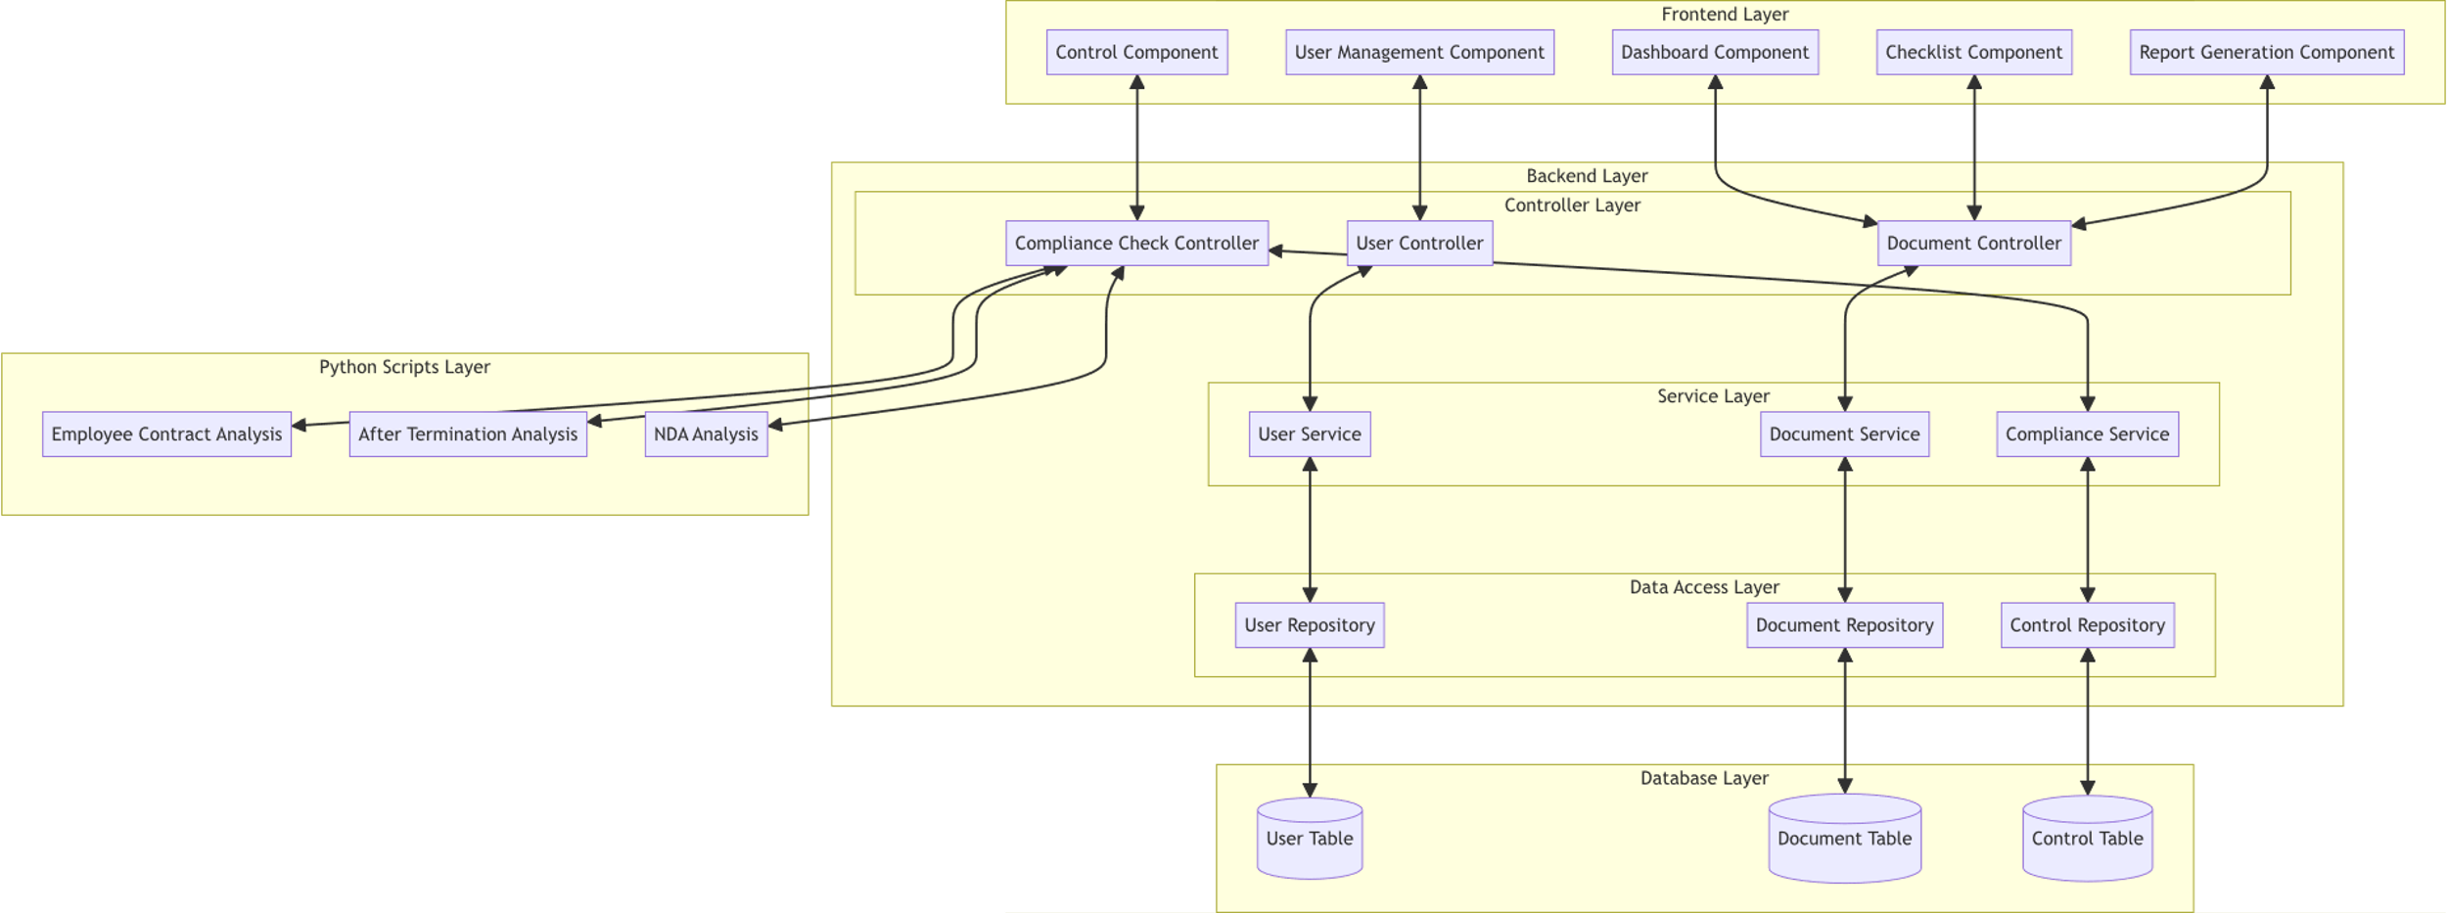

1. Frontend Layer
Separation of Concerns:
- Divided into distinct, reusable components, each handling specific responsibilities.
- Components are generalized for extensibility (e.g., adding new report types).
Components:
- User Management Component: Handles registration, login, and authentication-related functionality.
- Dashboard Component: Displays an overview of compliance controls and progress.
- Checklist Component: Manages and displays individual compliance controls, including their statuses and file uploads.
- Control Component: Handles automation-specific interactions, like triggering scripts or uploading files for individual controls.
- Report Generation Component: Handles the creation and display of compliance reports.
2. Backend Layer
Divided into three logical sublayers:
- Controller Layer: Entry point for API requests, responsible for handling user inputs and returning appropriate responses. Each controller focuses on a specific domain:
- User Controller: Handles user-related operations like registration and login.
- Document Controller: Handles operations related to document uploads and retrievals.
- Compliance Check Controller: Orchestrates compliance verification workflows and script execution.
- Service Layer: Contains the business logic of the application, separating it from request-handling logic. This ensures reusability and maintainability:
- User Service: Manages user-related business logic (e.g., validation, hashing passwords).
- Document Service: Processes file uploads and metadata storage.
- Compliance Service: Manages compliance verification, triggering Python scripts, and interpreting results.
- Data Access Layer: Encapsulates database queries into repositories, ensuring the database schema is abstracted from higher layers:
- User Repository: Interfaces with the User table for CRUD operations.
- Document Repository: Handles operations on the Document table.
- Control Repository: Provides access to predefined compliance controls stored in the Control table.
3. Database Layer
Remains unchanged structurally, but now interacts with the backend through well-defined repositories, ensuring clear separation of database logic.
4. Python Scripts Layer
- Isolated from the backend logic to improve maintainability.
- Each script focuses on a specific compliance check (e.g., employee contracts, termination policies, NDAs).
- The results are consumed by the Compliance Service, which processes the outcomes for higher-level application use.
How it achieves design goals:

1. Maintainability
- Separation of concerns across layers ensures that changes in one area (e.g., database schema) do not impact unrelated layers.
- Isolated responsibilities in the service layer make debugging and updates easier.

2. Reusability
- Generalized components (e.g., Checklist Component and Control Component) can be reused for new compliance controls or similar applications.
- Services and repositories can be extended or reused in other parts of the application.

3. Extensibility
- Adding new features (e.g., a new compliance control or report type) involves minimal changes:
- Define the control in the database.
- Create a new script or service logic.
- Extend the frontend with additional UI components.
- Backend layers are modular and can easily integrate new logic without impacting existing functionality.

4. Separation of Concerns
- Each layer and sublayer has a single responsibility:
- Controllers handle requests.
- Services handle business logic.
- Repositories abstract database access.
- Python scripts are isolated for compliance-specific analysis, ensuring clean integration.

Data Models
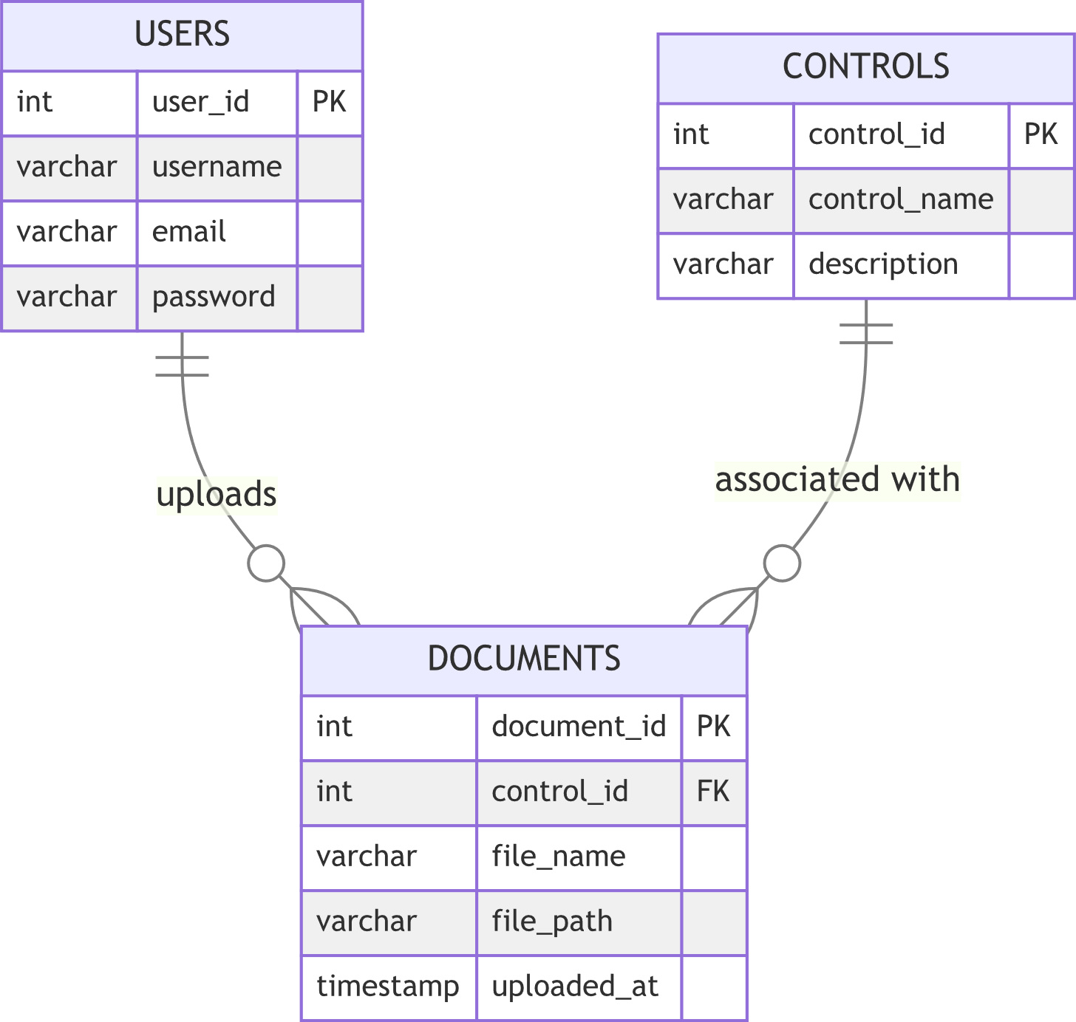

USERS

Represents the system’s registered users, such as compliance officers or IT administrators.

Fields:

user_id: (Primary Key): Unique identifier for each user.

username: User’s chosen display name.

email: User’s email address, used for login and identification.

password: User’s password (hashed in a production system).

DOCUMENTS
  - Stores metadata about uploaded documents used for compliance verification.
  - Fields:
    - document_id (Primary Key): Unique identifier for each document.
    - control_id (Foreign Key): References the control to which the document belongs.
    - file_name: Name of the uploaded file.
    - file_path: Path to the stored document on the server.
    - uploaded_at: Timestamp of when the document was uploaded.

CONTROLS
  - Represents the compliance controls that documents are checked against.
  - Fields:
    - control_id (Primary Key): Unique identifier for each control.
    - control_name: Name of the compliance control (e.g., "Confidentiality Agreement").
    - description: Brief description of what the control entails.

Relationships:
- USERS to DOCUMENTS:
  - A user can upload multiple documents, but each document is uploaded by a single user.
  - Represented by a one-to-many relationship.
- CONTROLS to DOCUMENTS:
  - A control can have multiple documents uploaded for compliance verification, but each document belongs to one control.
  - Represented by a one-to-many relationship.

Tools and Technologies

<List down tools and technologies that you are using for development and deployment. Make sure that you mention name and version of the tools.>

1. Backend
- Node.js: JavaScript runtime for building the server-side application.
  - Version: Latest compatible with the listed packages.
- Express: Minimalist web framework for Node.js.
  - Version: 4.21.1
- PostgreSQL: Relational database system.
  - Version: Compatible with pg 8.13.1.
- pg: PostgreSQL client for Node.js.
  - Version: 8.13.1
- dotenv: Environment variable management.
  - Version: 16.4.5
- cors: Middleware for enabling Cross-Origin Resource Sharing.
  - Version: 2.8.5
- multer: Middleware for handling file uploads.
  - Version: 1.4.5-lts.1
- child_process: Native Node.js module for executing external processes.
  - Version: 1.0.2
- socket.io: Real-time, bidirectional communication.
  - Version: 4.8.1

2. Frontend
- React: Library for building user interfaces.
  - Version: 18.3.1
- React-DOM: Provides DOM-specific methods for React.
  - Version: 18.3.1
- React-Scripts: Configuration and scripts for React apps.
  - Version: 5.0.1
- React Router DOM: Declarative routing for React.
  - Version: 6.28.0
- MDB React UI Kit: Material Design components for React.
  - Version: 9.0.0
- Web Vitals: Library for measuring performance metrics.
  - Version: 2.1.4
- @testing-library/react: React DOM testing utilities.
  - Version: 13.4.0
- @testing-library/jest-dom: Custom Jest matchers for testing.
  - Version: 5.17.0
- @testing-library/user-event: Simulates user events.
  - Version: 13.5.0

3. Python
- Python: Programming language for data processing and AI integration.
  - Version: 3.8+ (compatible with all listed libraries).
- PyPDF2: Library for reading and manipulating PDF files.
  - Version: Compatible with PyPDF2 latest.
- OpenAI: Client library for GPT models.
  - Version: Compatible with latest API.
- dotenv: For loading environment variables.
  - Version: Latest
- Pathlib: Path manipulation.
  - Version: Standard in Python 3.8+
- JSON: Standard Python module for JSON parsing.

4. Development Tools
- VS Code: Integrated Development Environment (IDE).
  - Version: Latest stable version.
- Postman: For testing API endpoints.
  - Version: Latest available.
- pgAdmin: PostgreSQL database management tool.
  - Version: Compatible with PostgreSQL.

5. Deployment
- Node Package Manager (npm): Package manager for Node.js.
  - Version: Latest stable.
- Git: Version control system.
  - Version: 2.30+
- Docker (Optional): For containerized deployment.
  - Version: Latest stable.

Who Did What?

Name of the Team Member | Tasks done
S. M. Aqdas Rizvi | Created diagrams and explanations
Ammad Akram | Reviewed document and provided information on data model
Shabbir Kamal | Reviewed document and provided information on prototype architecture
Rida Bilgrami | Reviewed document and provided information on technologies used

Review checklist

Before submission of this deliverable, the team must perform an internal review. Each team member will review one or more sections of the deliverable.

Section Title | Reviewer Name(s)
Data Model | Ammad Akram
Prototype Architecture | Shabbir Kamal
Technologies Used | Rida Bilgrami

